# Setup Guide

## Download required software

Ready to start. First you will have to set up the environment. This can take some time. So grab a coffee and get ready.

### Download VSCode

VSCode is a code editor that can be used to code-debug-run your program. It is the most widely used tool among developers and we encourage you to use it as well! Though feel free to use any editor of your choice.

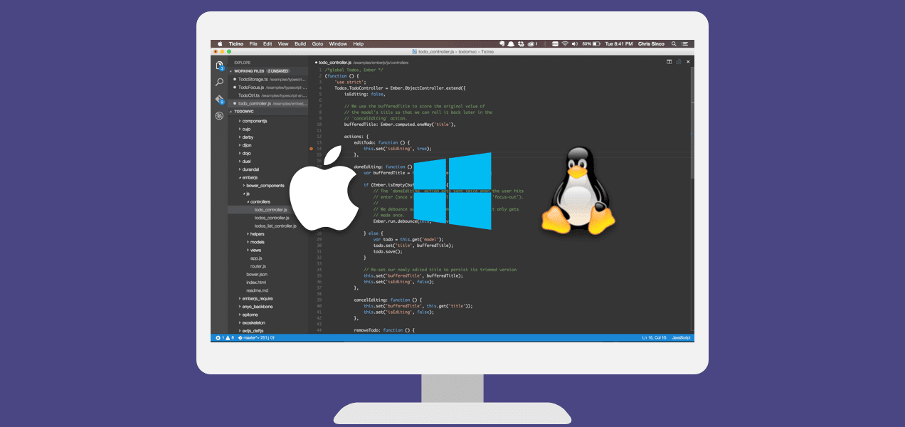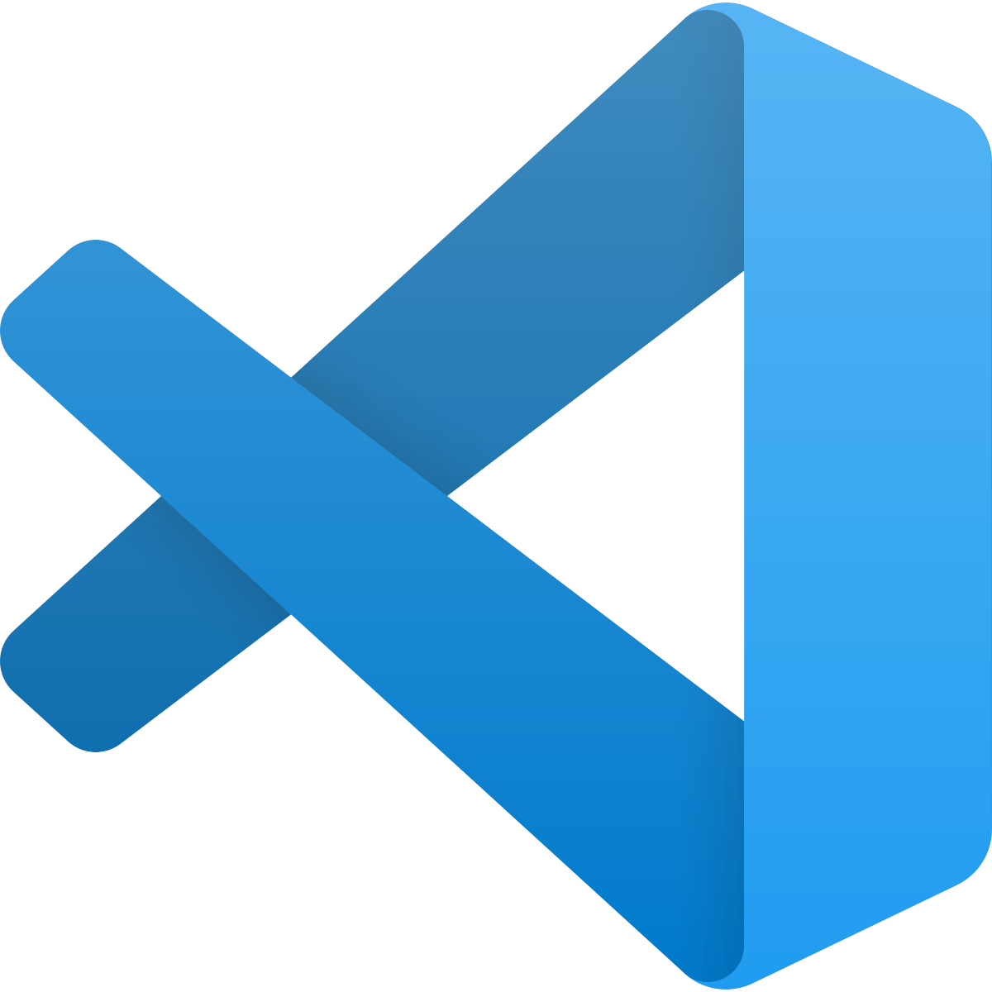

Here is a link to help Windows and Mac users download VSCode: <https://www.youtube.com/watch?v=bN6DE-4uFNo>

### **Download the installation package**

We have provided you with [**some files**](https://drive.google.com/drive/folders/1jAcrA0P0eLxnGqCFpp1by26u5wKs8qDR?usp=sharing), including the game environment, and all the agents template.. Make sure this is downloaded in the folder. This contains the code to set up the bomberman game. Feel free to open this file and go through the different folders. But do not change anything.

## Setting up a virtual local environment

Now that you have the installation package ready, you need to run it now. It turns out that the game has certain dependencies which do not match your system. Basically, our game is a little stubborn. We cannot change your computer configuration, because this might affect your other projects. So to solve this, we are going to run a local virtual environment on your system.

### Windows

#### A. Permissions

1. Click on 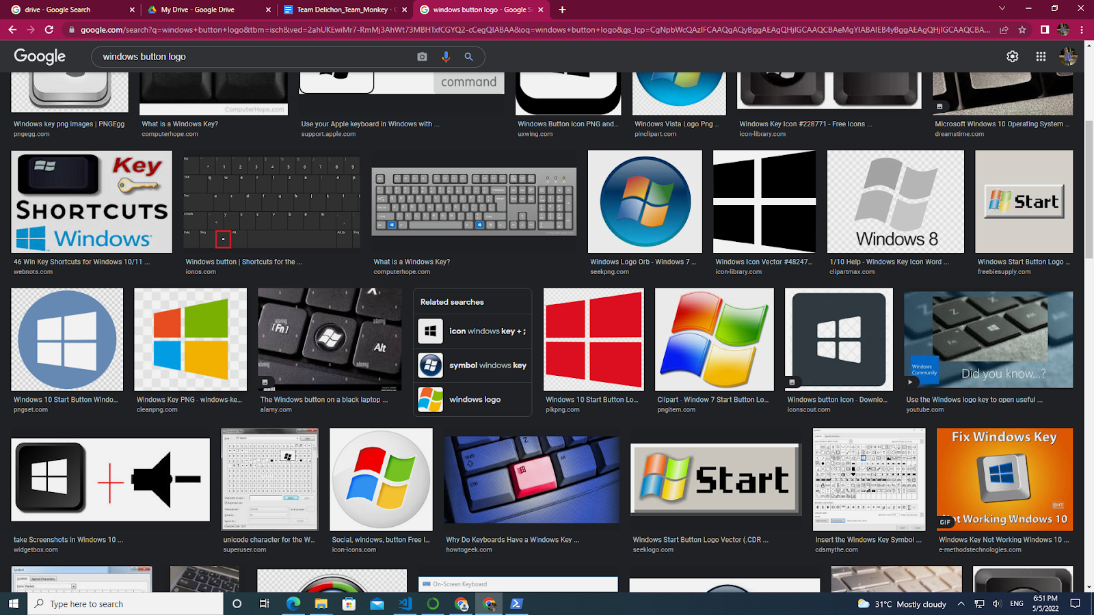 and search **Windows Powershell**. Select **Run as Administrator**

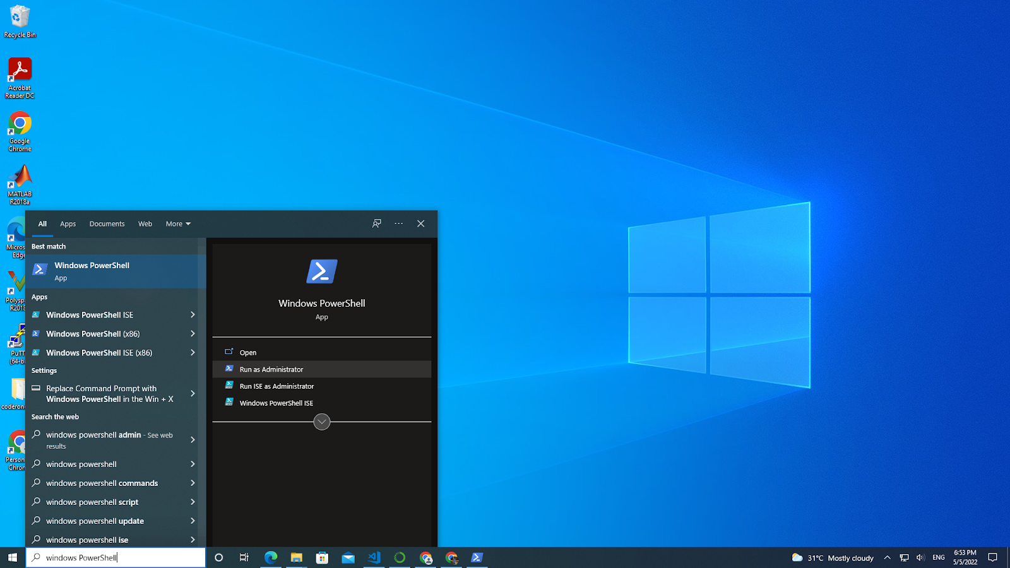

1. A powershell script will open as shown below  
   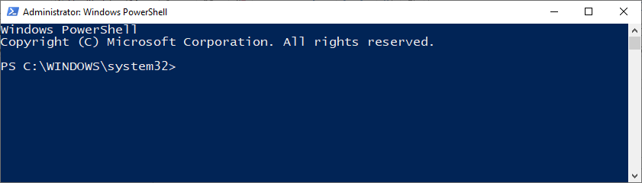
2. Enter the following list of commands as shown in the terminal. You can copy paste the commands from the text below.

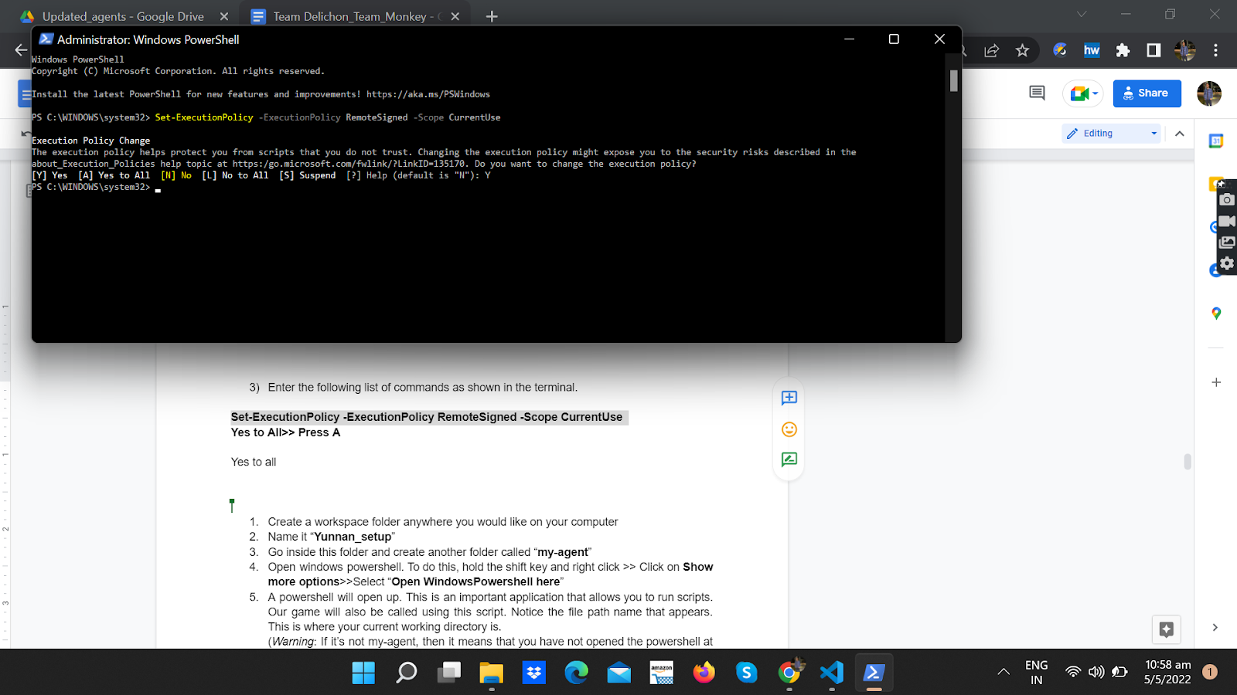

**Set-ExecutionPolicy -ExecutionPolicy RemoteSigned -Scope CurrentUse**

**Yes to All>> Press A**

#### B. Installing and setting up the background

1. Create a folder anywhere you would like on your computer. Call it **workspace**
2. Inside the folder, create a folder called **Yunnan_Setup**
3. Go inside **Yunnan_Setup** and create another folder. Call it **my**-**agent**. This is how your working directory should look like. (Note the file path order: workspace>Yunnan_setup>my_agent).   
     
   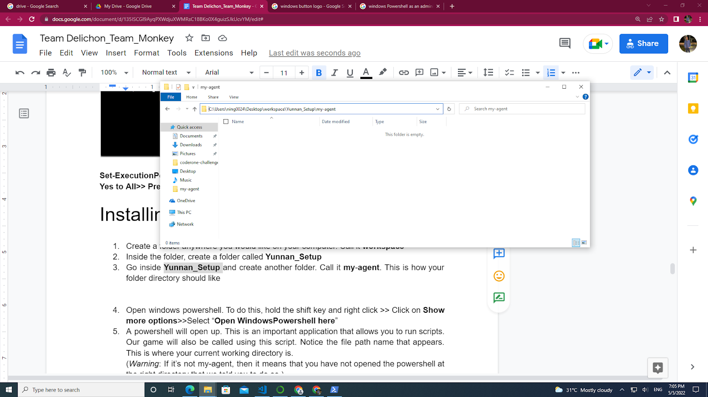
4. Open windows powershell. To do this, hold the shift key and right click >> Click on **Show more options**>>Select “**Open WindowsPowershell here**”  
   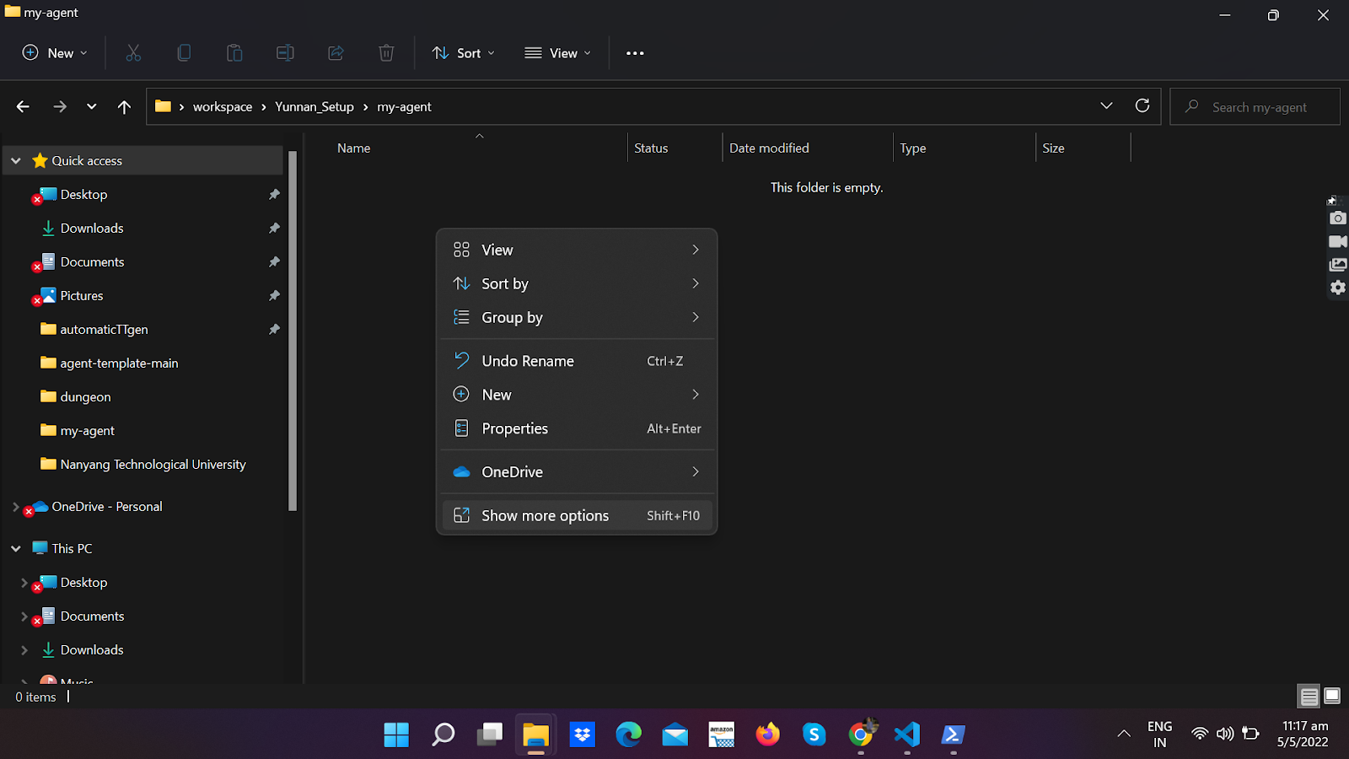  
     
   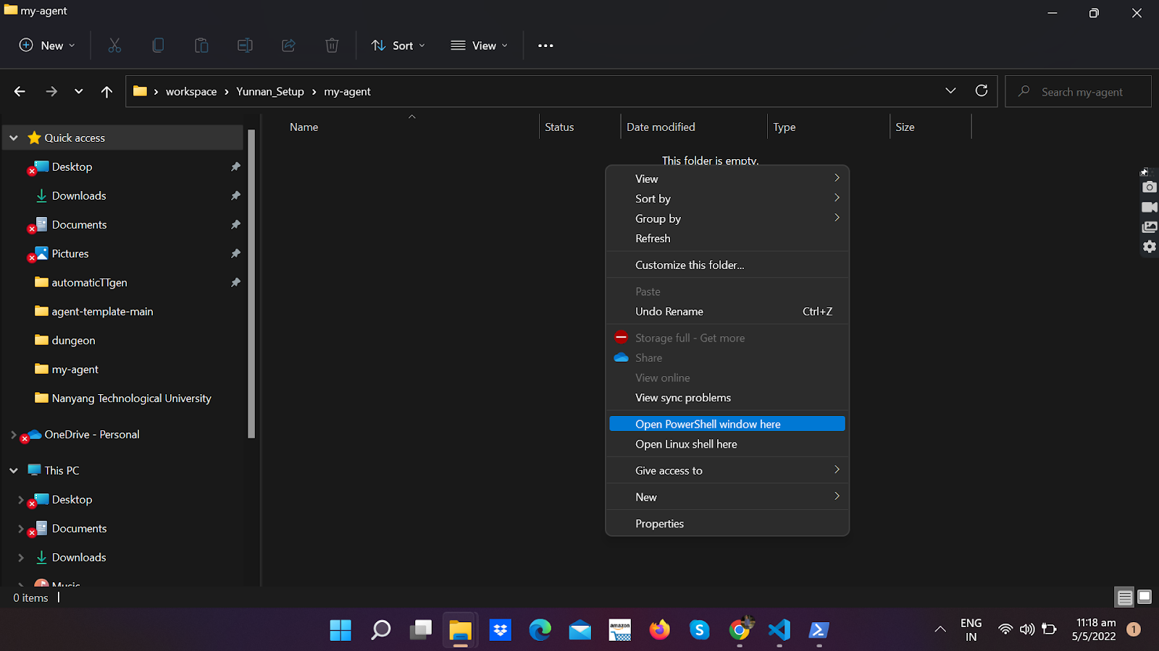
5. A powershell will open up. This is an important application that allows you to run scripts. Our game will also be called using this script. Notice the file path name that appears. This is where your current working directory is.   
     
   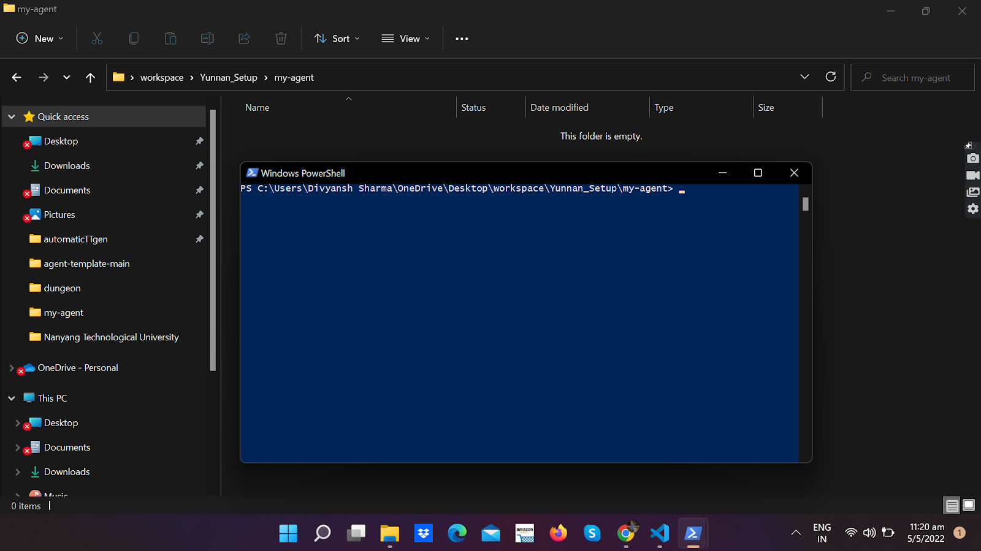  
     
   (*Warning*: If it’s not my-agent, then it means that you have not opened the powershell at the right directory that we told you to do so.)
6. Make sure you are in the my-agent directory inside the powershell. Now you need to create a virtual environment. Run the command:
7. Now create the virtual local environment using this command
8. Make a new python environment  
    **python -m venv venv**
9. Activate your virtual local environment by running

**.(space)venv/scripts/activate**

**. venv/scripts/activate**

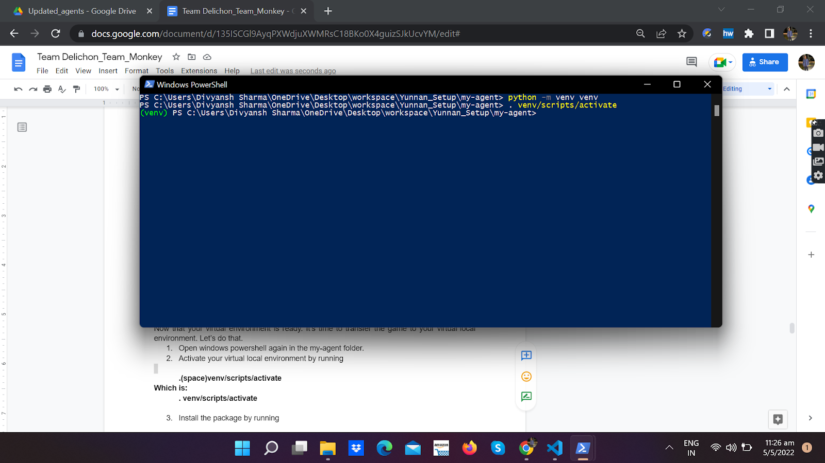

#### C. Installing the package

Now that your virtual environment is ready. It’s time to put your game in it. Let’s do that.

1. Transfer your **coderone-challenge-dungeon-0.1.6.zip** into the **my-agent** file. The contents of your my-agent file should appear as follows:  
     
   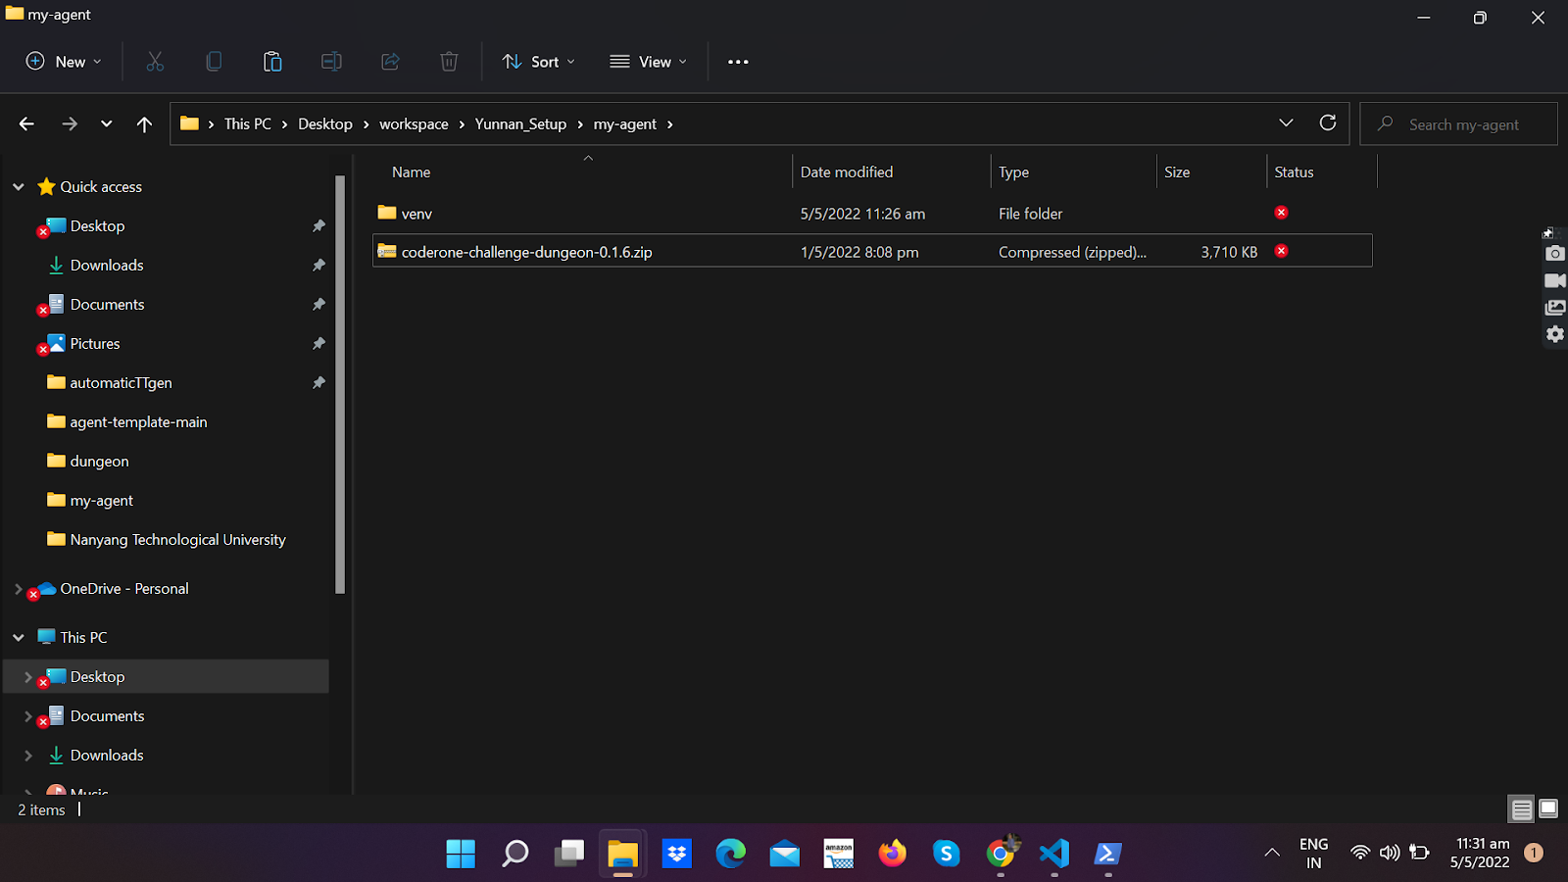
2. Go back to your powershell. Make sure your virtual environment is still activated(there should be (venv) preceding the file path). If your virtual environment is not active, or if you have reopened the powerShell, go back to step 9 and repeat. Install the package by running:

**pip install coderone-challenge-dungeon-0.1.6.zip**

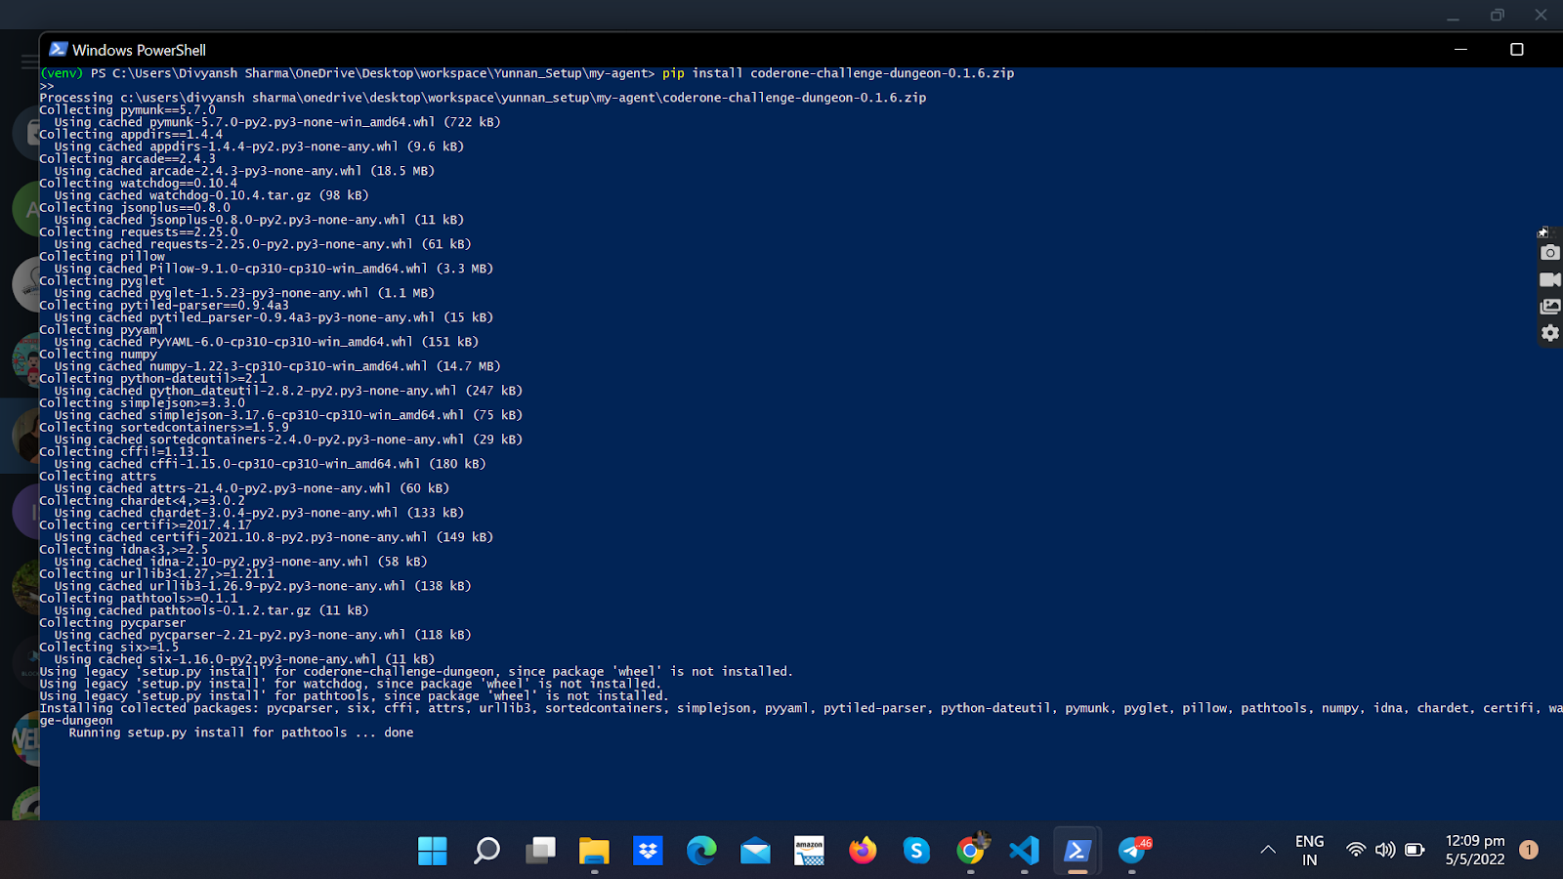

The above instruction might take some time. Do not terminate this process in the middle

1. Wow you have successfully installed and ran your environment. It’s time to execute and see this environment
2. Run the following command

coderone-dungeon --watch coderone.dungeon.agent coderone.dungeon.agent

Wow ! The game setup looks ready. Try moving your agent around. Now we are ready to code your agent

### Mac

#### A. Check if Python is installed on Mac

1. Open **Terminal** (Cmd + Space -> Type “Terminal" -> Press return)
2. Type the command python –version (double dash)
3. If Python is already installed on your Mac (which it should be) you will see this



Where 3.8.8 is the version. Your Python version should be 3.x.x.

1. If Python is NOT installed, you can download it from this page: [python.org/downloads/macos/](https://python.org/downloads/macos/)

#### B. Set up the virtual environment

1. **Create the directory** you want to install in and navigate to that place. E.g. I want to install it in ~/Documents/Ketchups/ARSC-competition

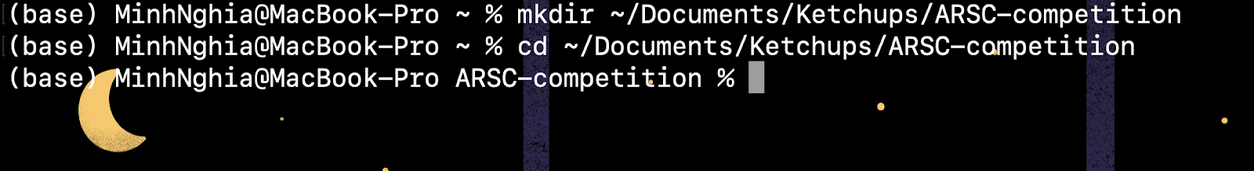

1. **Create a virtual environment** (I name it myenv, you can name it something else): Type in

python -m venv myvenv

and press Return

\**Note*: You can replace myenv in the command with your desired virtual environment name



After that, you should see a directory called ‘myenv’ (Or your environment name) inside the ARSC-competition directory.

1. **Activate the virtual environment** by typing in the command

source myenv/bin/activate

where myenv is your virtual environment name

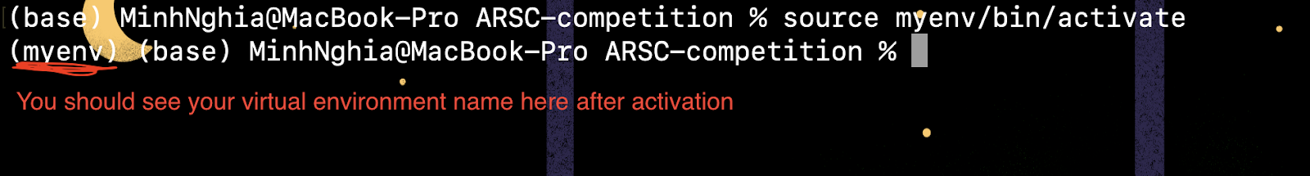

1. Install the coderone-challenge-dungeon-0.1.6.zip package

pip install <path to your .zip package>



Press Return and wait

1. To test if the installation is in place, type

coderone-dungeon --watch coderone.dungeon.agent coderone.dungeon.agent

**Note: From this point onward, i.e. the “creating an agent" and “running an agent", it is mostly the same on Mac.**

**Note 2: The ARSC-competition directory in the above example is similar to the my-agent folder in the Windows guide and the below part.**

### M1 Macs (with Anaconda)

#### Issue

Sometimes, installing the coderone-challenge-dungeon-0.1.6.zip through pip using the “normal” Python (the Python versions installed on Mac) may result in errors; we suspect that it is due to packages’ incompatibility with M1 architecture.The error message could be as follow:

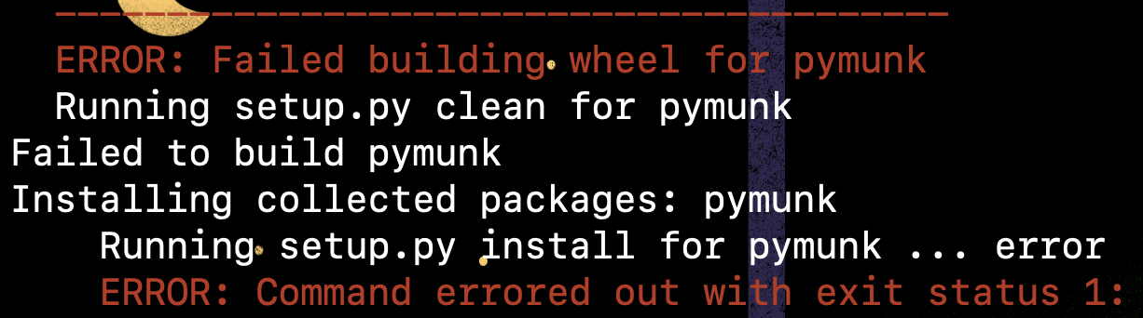

…or similar installation errors with one or more of these packages: **pillow**, **numpy** and especially **pymunk**.

#### Workaround using Anaconda:

**(For those who are already familiar with Anaconda)** Create and use a conda environment (managed by Anaconda) as your virtual environment and proceed with the installation as guided. Remember to choose the right virtual environment and Python interpreter in VSCode!

**Step-by-step guide:**

1/ [Download and Install Anaconda](https://www.anaconda.com/products/distribution#Downloads)

2/ Open **Anaconda-Navigator**

3/ Go to **Environments** -> **Create** -> **Type the name for your new conda environment** (No space)-> **Create**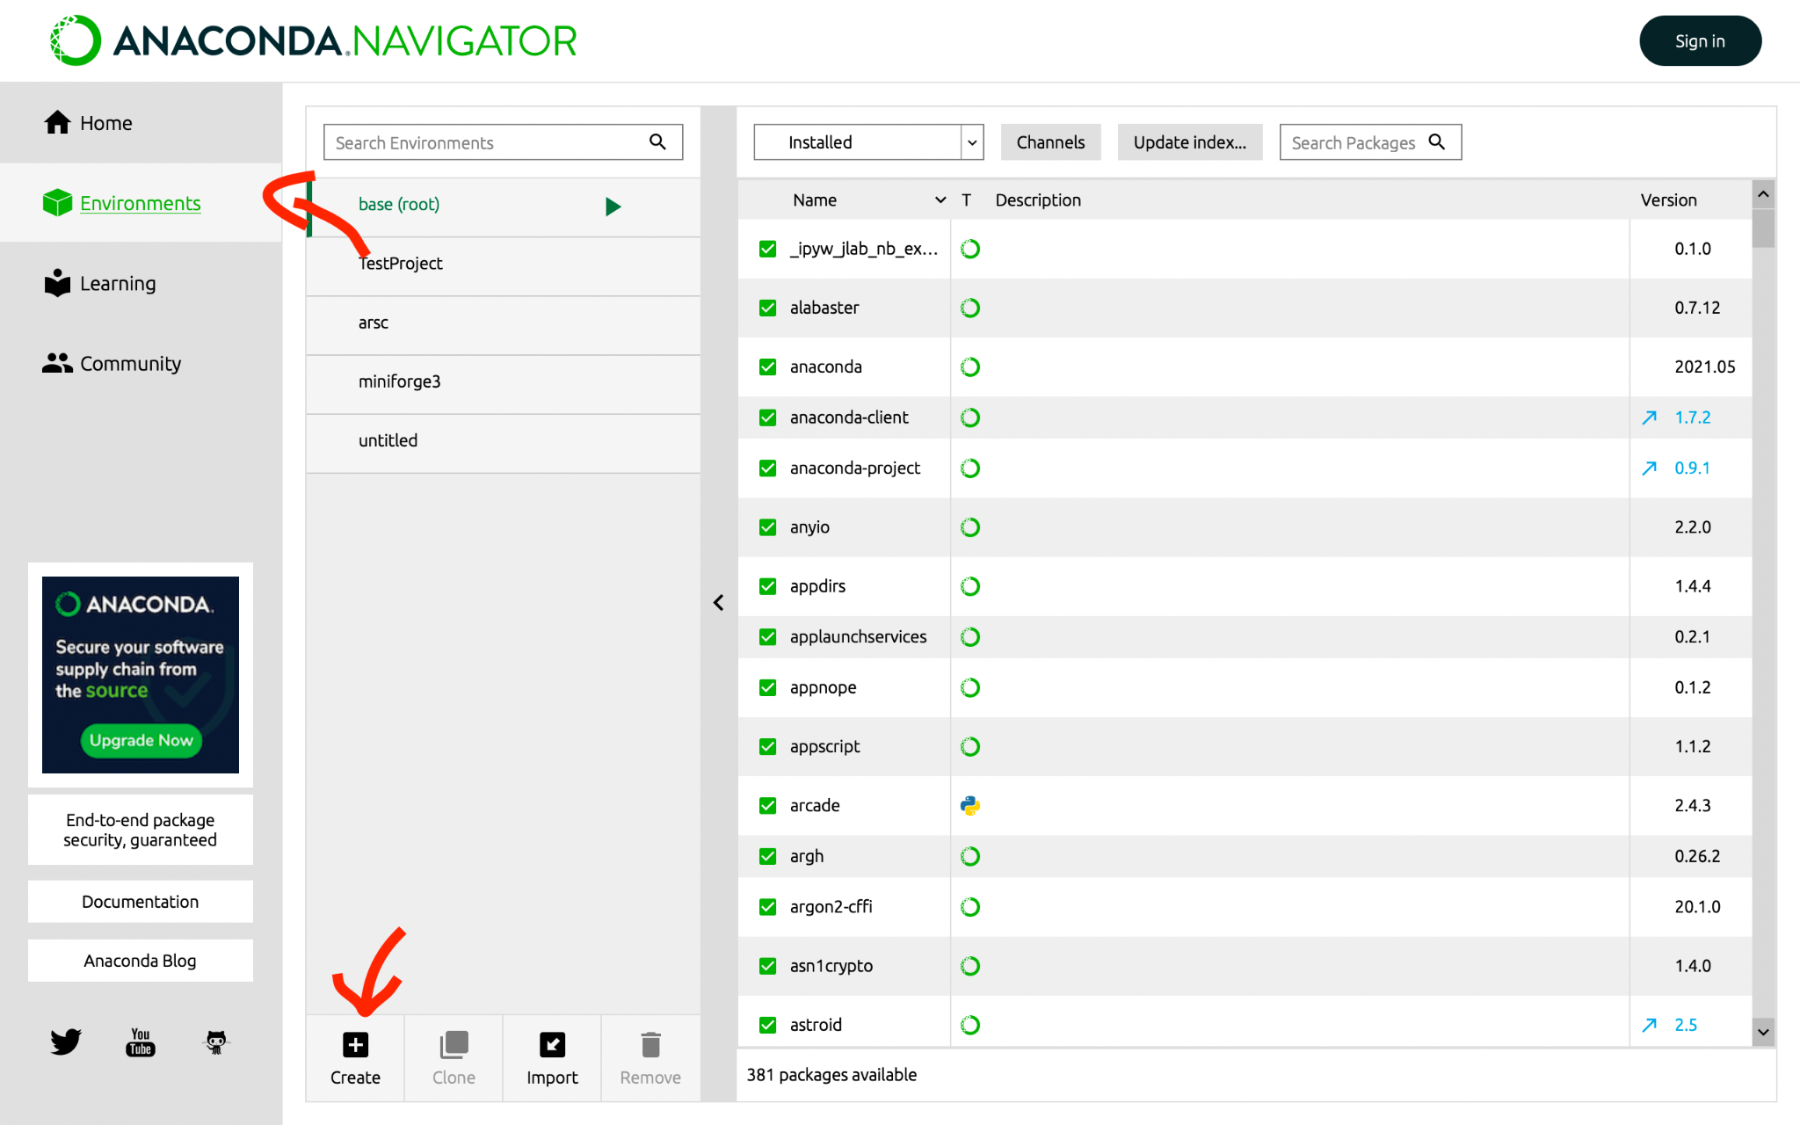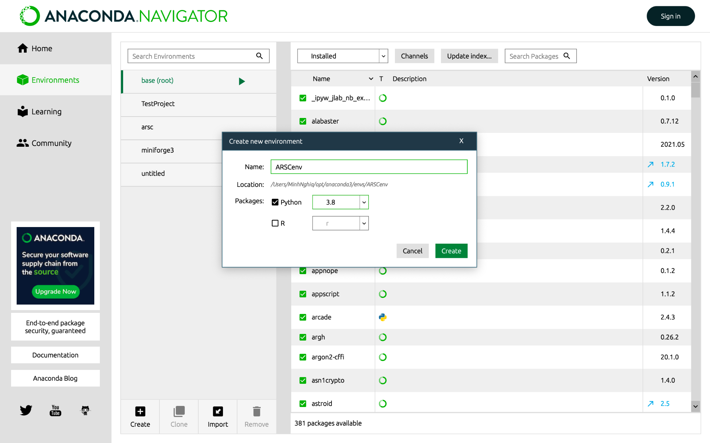

4/ Select your newly created environment from the list -> Click the play button next to the environment name -> Select ‘Open Terminal’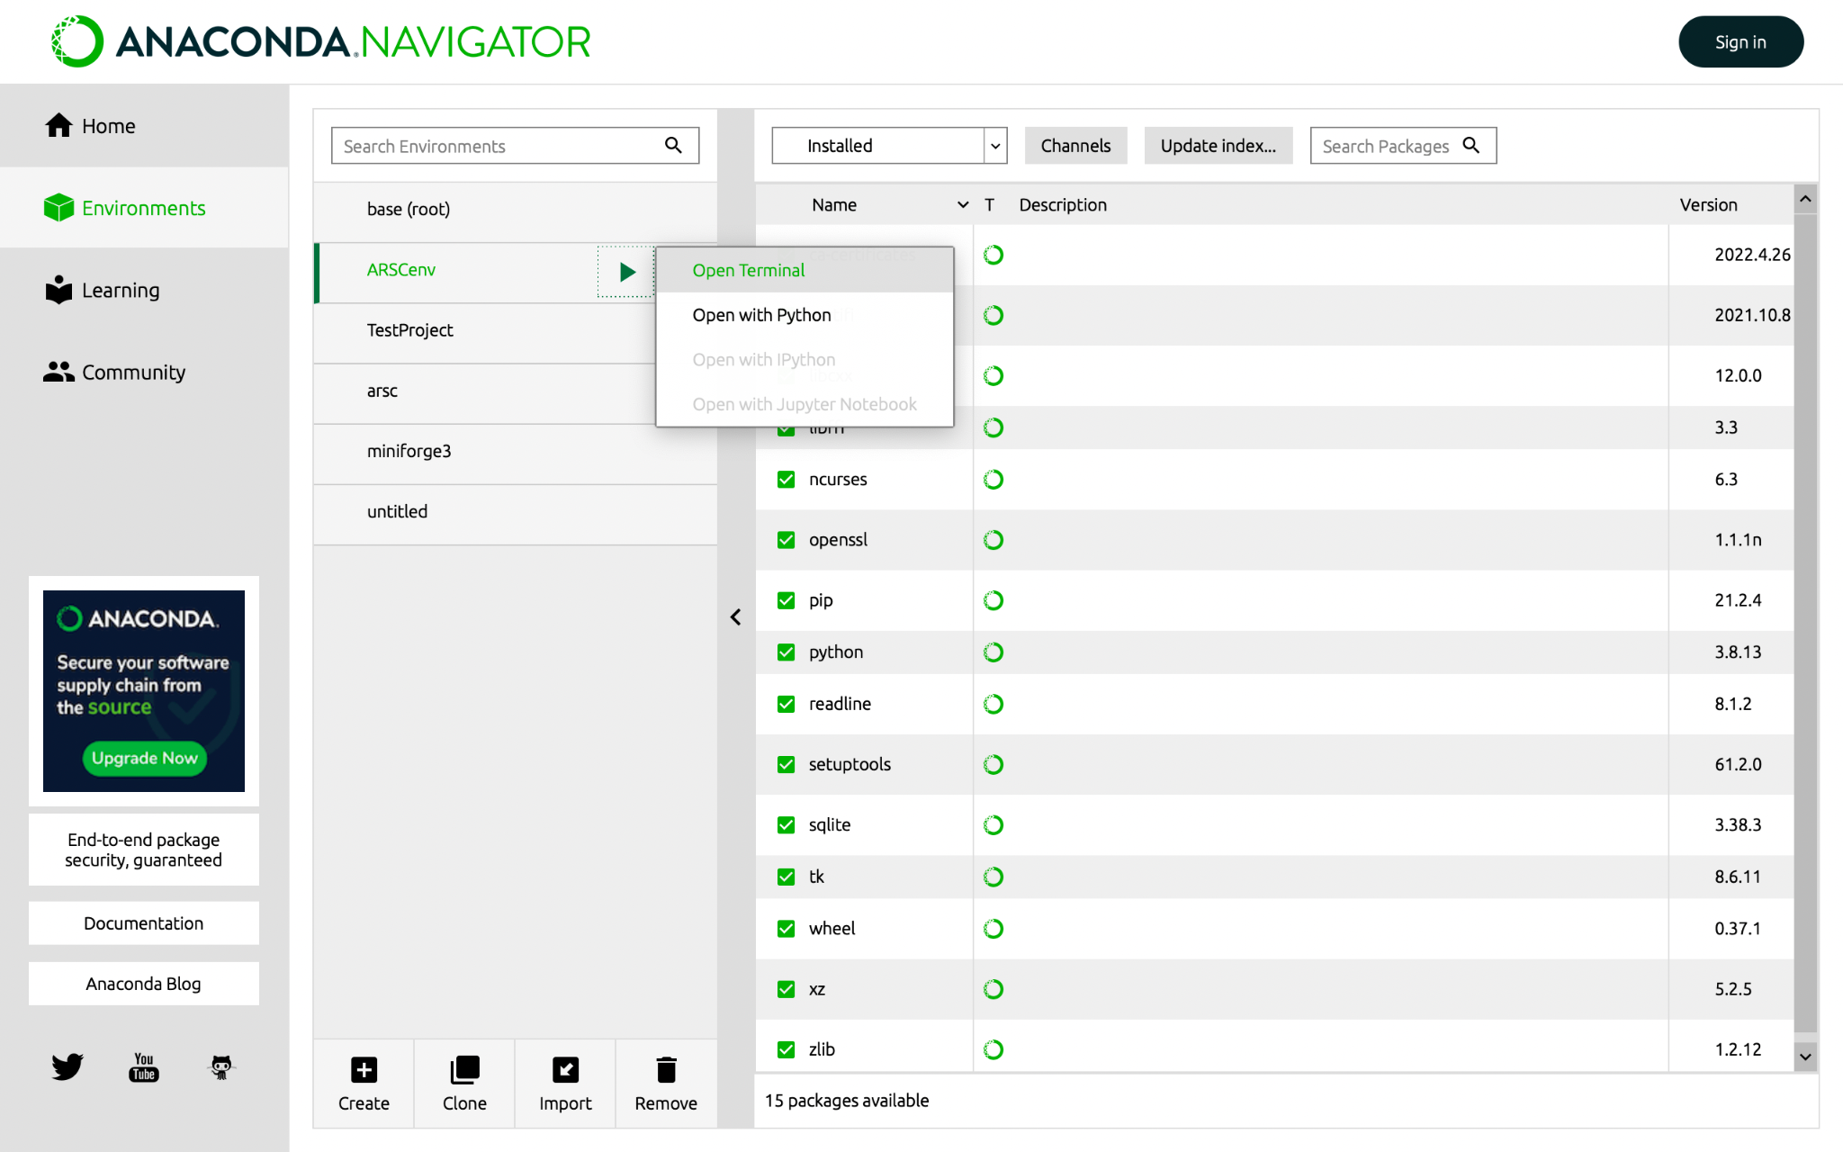

This will open a Terminal with your conda virtual environment activated. You should see **(your-env-name)** at the start of the command line.

5/ Proceed with the installation as usual, but **skip** the steps **create a virtual environment** and **activate the virtual environment**. (Because you have just created a virtual environment and activated it)

Now, whenever you work with this project (including running the game), follow **step 4** to open a Terminal with the environment activated.

6/ Open in VSCode the folder of your project, press **Shift + Cmd + P** -> Type and choose **Python: Select Interpreter**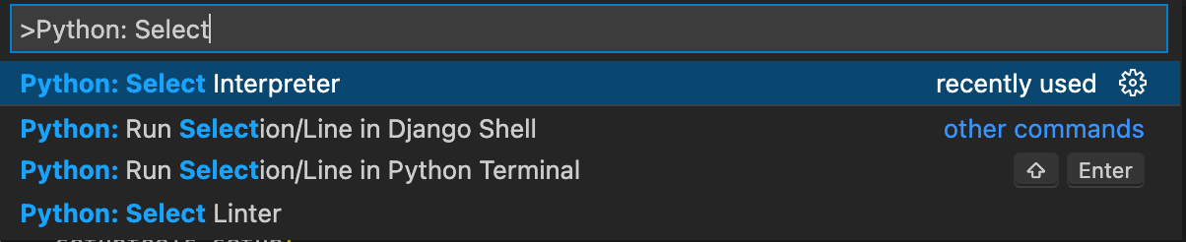

7/ Choose the one with the environment you just created in the list (it’s in the ‘Conda’ section)

